7. Z Axis Assembly

Vitamins
2 M3 cap screw x 16mm  4 M4 cap screw x 16mm  2 Nyloc nut M3  4 Nyloc nut M4  4 LM8UU bearings | 2 Smooth rod 8mm x 336mm  2 Smooth rod 8mm x 451mm  2 Threaded rod M5 x 300mm  2 Washer M3 x 7mm x 0.5mm  4 Washer M4 x 9mm x 0.8mm

Printed parts
2 z_bar_clamp.stl
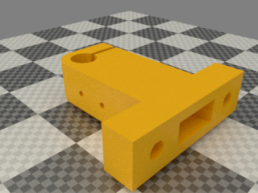

Sub-assemblies
1 x_motor_assembly | 1 x_idler_assembly | 2 z_motor_assemblies | 1 xendstop_45mm assembly

Assembly

- Insert the M3 nyloc nuts into the nut traps inside the bar clamps and M4 nylocs into their base.
TIP: add 1-2 washers in the gap and use a screw that is long enough to go all the way through the clamp and catch the nut.. use the screw to guide it in to the nut trap. Use the final screw with the washers in place to gently home the nut. Remove the washers in the gap
- Fit M3 x 16mm cap screws and washers to the bar clamps.
- Attach the bar clamps to the top of the gantry using M4 x 16mm cap screws, note that they both face the same way, i.e. they are not symmetrical. Leave the screws loose.
- Take the motor x end and use an 8mm drill to clean up the holes for the smooth rod. Dont go any deeper than 42mm not counting the coned part of the drill. Blow out any plastic
- degrease each rod on its entire length and mark each of the smooth rods excatly 42mm from the end
- drill out the 8mm holes in the endstop. This has to be done with the 2 3mm screws removed. Reinsert the screws when done
- slide the endstop on to the smooth rods so that they pass the 42mm marks
- Press the smooth rod in to the motor x end. Lightly tapping with a hammer might be needed
- now mark the rods at 369mm
- slide on 2 LM8UU bearings on each rod
- drill out the idler holes in the same way and press them on the rods until they reach the 369mm markings. If you need to tap with the hammer you can do so on the adjustment screw at the end of the idler assembly
- degrease and fit the Z bars (smooth rods), inserting them through the X ends. Tighten the left hand bar clamp but leave the right hand one loose.
- Thread the isolators onto the bottom of the lead screws (threaded rod) about 100mm of the way up.
- Push each X end to the top and insert the lead screw from underneath far enough to allow the bottom end to go into the top of the couplings.
- Orientate the couplings so that the flat on the motor shaft is facing towards the gap and then tighten the screws.

